

Artificial Intelligence and Machine Learning
(6CS012)
Title: Task II Vision Task(Scene Classification)
(Report)

Student Name : Rajiv Khattri
University Id : 2408207
Course : BSc (Hons) Computer Science

Tutor : Ms. Jenu Nyachhyon

Submitted on : 10 May 2026

Abstract
This report outlines a full end-to-end deep learning report for the 6-class natural scene image classification task with the Intel Image Classification Dataset (17,034 images of three classes: Buildings, Forest, Glacier, Mountain, Sea, and Street). The study comprised of two tasks: designing, training, and evaluation of CNNs from scratch (Part A) and transfer learning for pre-trained VGG16 CNN model (Part B).
A Baseline CNN (3 Conv+Pool blocks, 3 fully connected layers) has a Test accuracy of 85.07% in Part A. A Deeper CNN (6 Conv layers, Batch Normalization, Dropout) trained with Adam obtained 84.90% and the same architecture trained with SGD+Nesterov obtained 80.17% which is a proof of the superiority of Adam, in a limited number of epochs. The value of Dropout was validated in an ablation study in which it was removed, leading to a drop in accuracy to 81.20% and a doubling of the overfitting gap from ~4% to ~8%.
In Part B, VGG16 pre-trained on ImageNet was fine-tuned using a two-stage process: freezing the layers of the VGG16 network and fine-tuning the layers of the network block5 at LR=1e-5. VGG16 also outperformed all the scratch-trained models by at least 5.8 percentage points with test accuracy of 90.87%. There was a high level of inter-class confusion between glacier and mountain type across all models with confusion continuing over time. The findings clearly show that the advantage is significant and that the results obtained from transfer learning is better than training from scratch, with the datasets being this size and complexity.

Table of Contents
Abstract 2
1. Introduction 1
2. Dataset 1
2.1 Source and Overview 1
2.2 Class Distribution 2
2.3 Image Characteristics 3
2.4 Visual Samples 4
3. Methodology 5
3.1 Data Preprocessing and Augmentation 5
3.2 Baseline CNN Architecture(Part A) 6
3.3 Deeper CNN Architecture(Part A) 6
3.4 Optimizer Comparison: Adam vs SGD + Nesterov 7
3.5 Ablation Study – Effect of Dropout 7
3.6 Transfer Learning – VGG16(Part B) 7
3.7 Evaluation Metrics 8
4. Experiments and Results 8
4.1 Baseline CNN 8
4.2 Deeper CNN vs Baseline 11
4.3 Optimizer Comparison: Adam vs SGD+Nesterov 13
4.4 Ablation Study – Effect of Droupout 15
4.5 Part A Summary 17
5. Transfer Learning – VGG16(Part B) 17
5.1 Model Selection and Justification 17
5.2 Stage 1 – Freezing Extraction 18
5.3 Stage 2 – Fine Tuning 19
5.4 Evaluation Results 20
5.5 Does Transfer Learning Outperform Training from Scratch? 21
5.6 Final Cross Model Comparison 22
6. Conclusion and Future Work 23
6.1 Key Findings 23
6.2 Limitations 23
6.3 Future Work 23
6.4 Computational Notes 24

Table of Figures
Figure 1: Class Distribution - Training vs Test split across all six scene categories 8
Figure 2: Representative sample images from all six scene categories showing intra-class diversity. 9
Figure 3: Data Augmentation Samples - Original (top-left) and augmented variants of a Mountain class image. 10
Figure 4: Baseline CNN - Training vs Validation Loss (left) and Accuracy (right) over 15 epochs. 13
Figure 5: Baseline CNN - Confusion Matrix on the 3,000-image test set. 14
Figure 6: Baseline CNN - Sample predictions. Green = correct, Red = incorrect. 15
Figure 7: Deeper CNN (Adam) - Training vs Validation Loss and Accuracy over 20 epochs. 16
Figure 8: Deeper CNN (Adam) - Confusion Matrix. 17
Figure 9: Deeper CNN with SGD+Nesterov - Loss and Accuracy curves over 20 epochs. 18
Figure 10: Deeper CNN (SGD) - Confusion Matrix. 19
Figure 11: Ablation Study - With Dropout (left) vs Without Dropout (right). Note widening train-val gap on the right. 20
Figure 12: No Dropout Ablation - Confusion Matrix 21
Figure 13: VGG16 Stage 1 (Feature Extraction) - Loss and Accuracy over 10 epochs. 23
Figure 14: VGG16 Stage 2 (Fine-Tuning block5) - Loss and Accuracy over 7 epochs. 24
Figure 15: VGG16 Transfer Learning - Confusion Matrix on the 3,000-image test set. 25
Figure 16: VGG16 - Sample predictions. Green = correct, Red = incorrect. 26
Figure 17: Final Model Comparison - Test Accuracy across all five models. 27

1. Introduction
Image classification is the fundamental problem in computer vision, which is also a key component of several applications, such as autonomous navigation, medical diagnostics, satellite imagery interpretation, and content moderation. Deep learning, specifically Convolutional Neural Networks (CNNs) that take advantage of spatial hierarchy by learnable convolutional filters, has revolutionized the process of assigning semantic labels to raw pixel data.
The goal of this project is to consider the problem of natural scene classification: given an outdoor image, classify it into one of six semantic categories. The difficulty comes from the fact that the intra-class variability or diversity of natural environments (a forest in summer vs. a forest in winter) is large, as is the inter-class visual overlap (glaciers and mountains share colour distributions; buildings and streets share urban structural features).
The research question that motivated this work is a group-proposed research question: Is it possible to use a CNN to classify natural outdoor scenes into 6 categories, and can transfer learning with a pre-trained CNN model be done better than when training a CNN from scratch? This is tackled by a systematic pipeline consisting of: (1) baseline architecture design, (2) deeper architecture with regularisation, (3) optimizer comparison, (4) ablation study, and (5) transfer learning using VGG16.
Several previous studies in this area have shown that, on large-scale benchmarks, adding layers to the network with proper regularization always boosts accuracy, such as AlexNet, VGGN and ResNet. Since then, transfer learning (Yosinski et al., 2014) has been the standard way to deal with moderate-sized datasets, by taking advantage of the features extracted from large-scale corpora for downstream classification problems.

2. Dataset

2.1 Source and Overview
Intel Corporation has released on Kaggle the Intel Image Classification Dataset as a natural image classification benchmark. The data was pre-approved by the module teacher before use. It consists of 17,034 natural images of outdoor scenes belonging to six semantic categories: Building, Forest, Glacier, Mountain, Sea and Street. The data is divided into two sets: 14,034 images for training and 3,000 images for testing.

2.2 Class Distribution
The distribution of these is given in Table 1. The number of training images for each class is approximately balanced, the largest class (Mountain, 2505) being no more than 15% higher than the smallest (Buildings, 2184), which is considered acceptable for standard accuracy to be the main evaluation metric, without needing to resort to class-weighting strategies.
Class | Training Images | Test Images | Total
Buildings | 2,184 | 437 | 2,621
Forest | 2,264 | 474 | 2,738
Glacier | 2,397 | 553 | 2,950
Mountain | 2,505 | 525 | 3,030
Sea | 2,267 | 510 | 2,777
Street | 2,375 | 501 | 2,876
Total | 13,992* | 3,000 | 16,992*
Table 1: Class-wise image distribution. *After removal of 42 corrupt files detected during preprocessing.

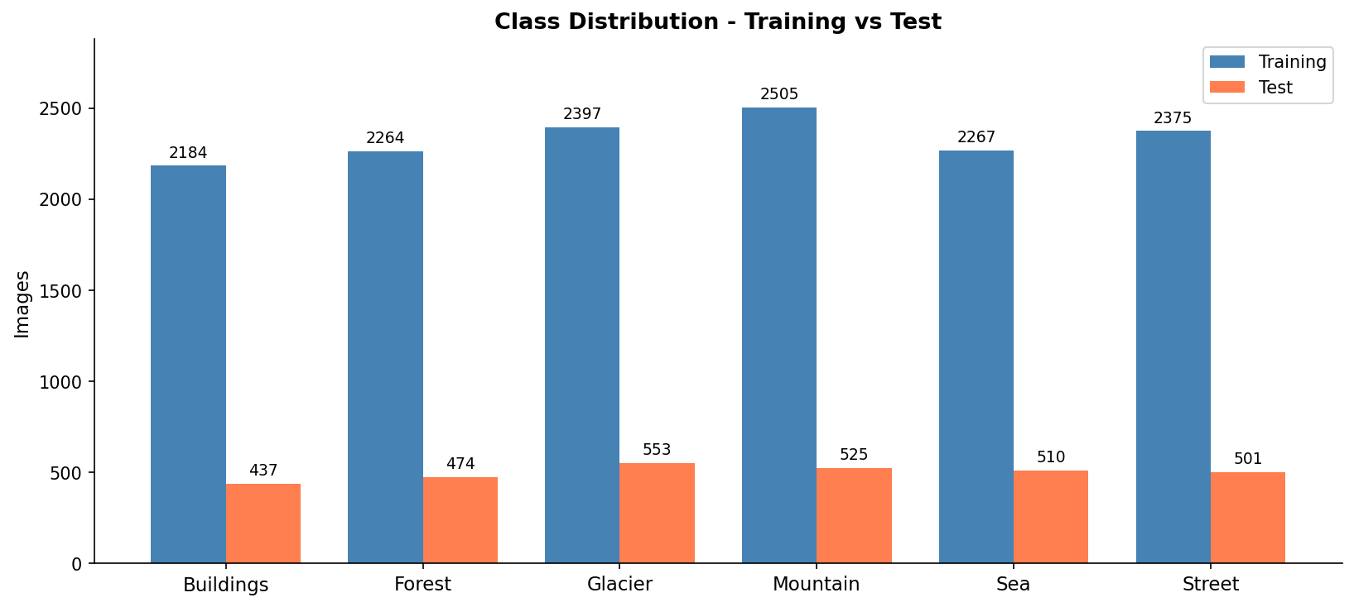
Figure 1: Class Distribution - Training vs Test split across all six scene categories

2.3 Image Characteristics
All images are JPEG encoded with three RGB color channels, and shot in a variety of real-world conditions at a resolution of ~150x150 pixels. In the pre-processing phase, 42 corrupt image files were found (7 each class), which are characterized by having very small file sizes corresponding to empty or truncated files. These were filtered out based on a file size threshold, programatically.

2.4 Visual Samples
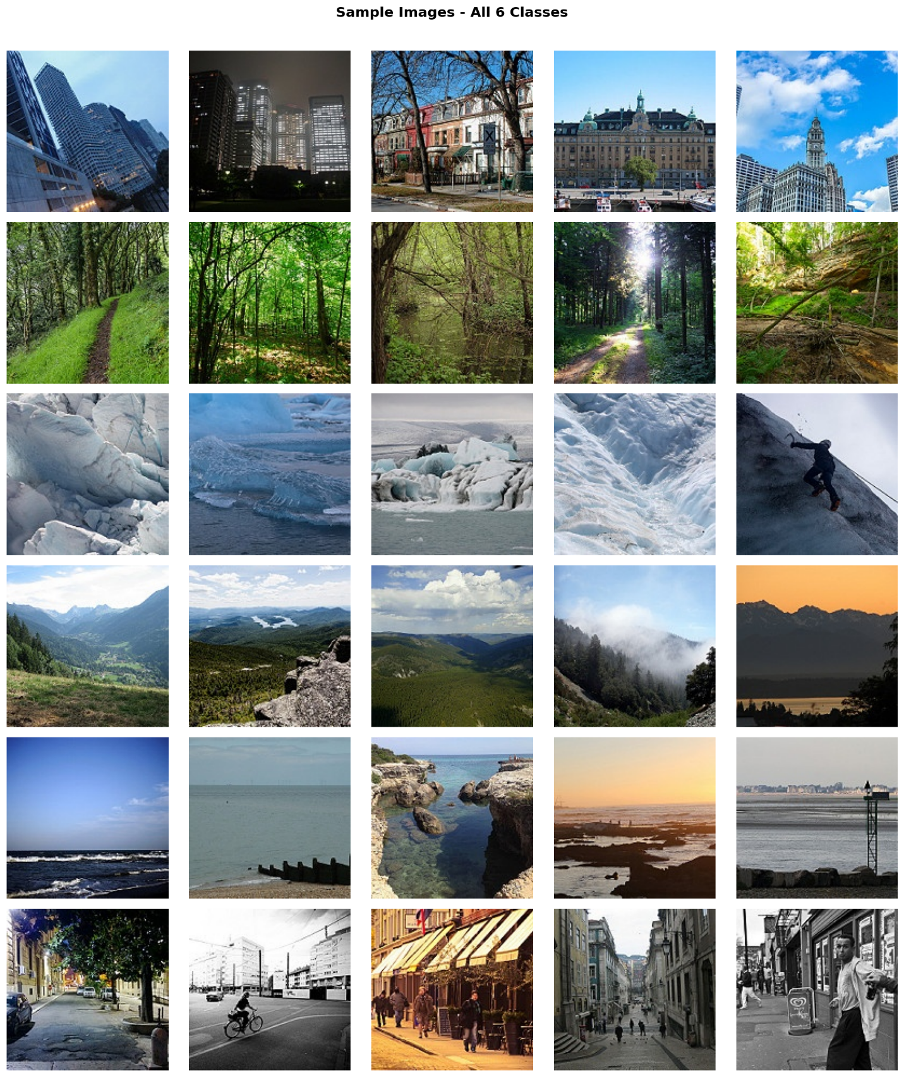
Figure 2: Representative sample images from all six scene categories showing intra-class diversity.

The biggest difficulty in glacier-mountain visual overlap is found in visualizing rocky terrain, which is a primary challenge of both classes, and in the similar color palettes in both classes. This is the most predominant inter-class confusion that was seen in all of the experiments and was identified during the preliminary data analysis of the group proposal.

3. Methodology

3.1 Data Preprocessing and Augmentation
The pixels were rescaled from a range of [0, 255] to [0, 1] using a rescale factor of 1/255. The training set was split into a validation set of 20%, with a fixed random seed, to provide around 11,200 training images and 2,800 validation images for model development in Part A.
Only the training generator was augmented with data to avoid data leakage. Horizontal flipping, horizontal and vertical translation (up to 20%), rotation (up to 20°), zooming (up to 20%) and fill mode 'nearest' were all part of the augmentation pipeline. These changes ensure that data is more diverse than what exists in memory and can be viewed as a form of regularization.
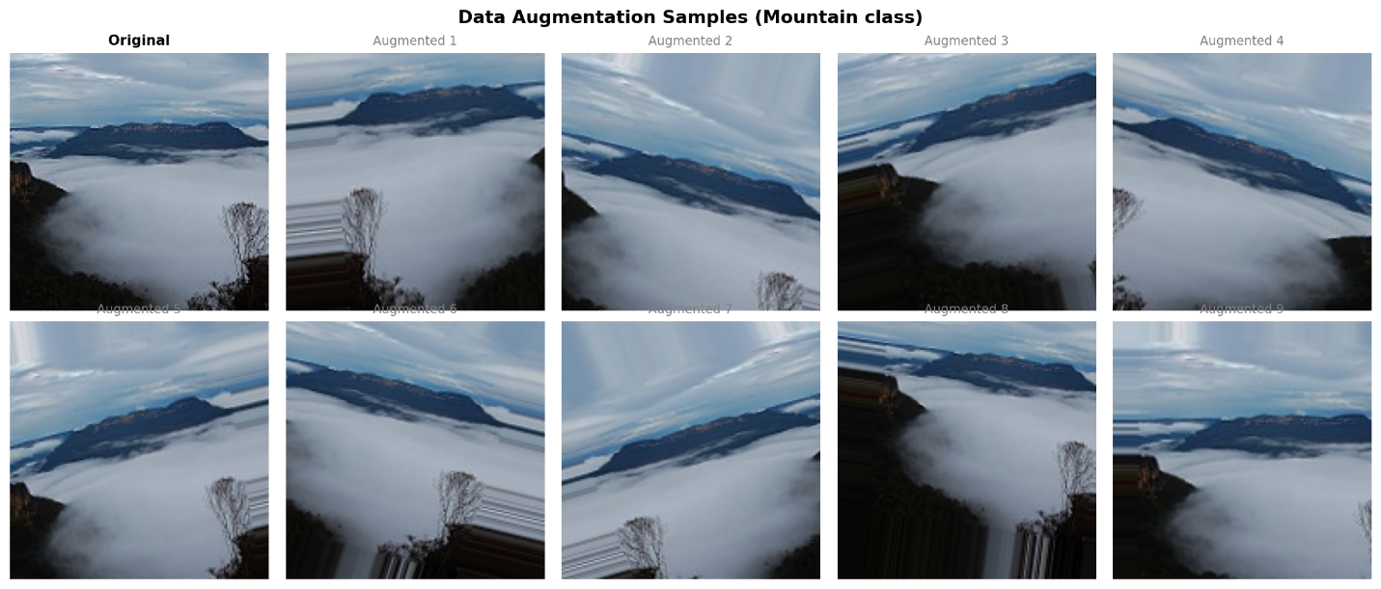
Figure 3: Data Augmentation Samples - Original (top-left) and augmented variants of a Mountain class image.
In Part B, images were cropped to a size of 224x224 pixels as VGG16 is expecting 224x224 images. Batch size was set at 32 for Part B (224x224) to not load too much into T4 VRAM and 64 for Part A (150x150) to gain the maximum throughput from the GPU.

3.2 Baseline CNN Architecture(Part A)
The baseline model has the same structure as described in the assessment brief: three convolutional layers followed by max-pooling, three fully-connected layers, and a softmax output layer. No smoothing was done to create a baseline of "fair performances.
Layer | Type | Configuration | Output Shape
Conv1 + Pool1 | Conv2D + MaxPool2D | 32 filters, 3x3, ReLU, same | 75x75x32
Conv2 + Pool2 | Conv2D + MaxPool2D | 64 filters, 3x3, ReLU, same | 37x37x64
Conv3 + Pool3 | Conv2D + MaxPool2D | 128 filters, 3x3, ReLU, same | 18x18x128
Flatten | Flatten | — | 41,472
FC1 | Dense | 256 units, ReLU | 256
FC2 | Dense | 128 units, ReLU | 128
FC3 | Dense | 64 units, ReLU | 64
Output | Dense + Softmax | 6 units, Softmax | 6
Table 2: Baseline CNN Architecture.
Composed using Adam optimizer and categorical cross-entropy loss. Training was done using EarlyStopping (patience=3, on val_loss) and ReduceLROnPlateau (factor=0.5, patience=2) with model checkpointing to Google Drive.

3.3 Deeper CNN Architecture(Part A)
The deeper architecture has six convolutional layers (3 blocks of 2 convolutional layers per block). In addition, Batch Normalization is performed after each Conv layer; Dropout is applied at a dropout rate of 0.25 after pooling blocks and 0.5 in the dense head.
Block | Layers | Filters | Regularization
Block 1 | 2x Conv2D + MaxPool2D | 32, 32 | BN after each Conv, Dropout(0.25)
Block 2 | 2x Conv2D + MaxPool2D | 64, 64 | BN after each Conv, Dropout(0.25)
Block 3 | 2x Conv2D + MaxPool2D | 128, 128 | BN after each Conv, Dropout(0.25)
FC Head | Dense(256)+BN, Dense(128), Dense(64) | — | Dropout(0.5) after 256 and 128
Output | Dense(6) + Softmax | — | —
Table 3: Deeper CNN Architecture.

3.4 Optimizer Comparison: Adam vs SGD + Nesterov
Both the deeper architecture and Adam, as well as SGD+Nesterov (LR=0.01, momentum=0.9), were trained under the same conditions: same architecture, same augmentation, same callbacks, and max 20 epochs. This makes the effects of the optimizer on convergence and final accuracy stand out.

3.5 Ablation Study – Effect of Dropout
The ablation model is the same as the deeper CNN model, but with the only difference being the removal of all the Dropout layers. The batch normalization is preserved. This controlled comparison measures Dropout's explicit contribution towards the task of generalization. EarlyStopping patience=3, with a max of 15 epochs.

3.6 Transfer Learning – VGG16(Part B)
The choice of VGG16 pre-trained on ImageNet was motivated by the fact that it has a very strong capacity for transferable feature representation for natural scene imagery, it is a sequential network and Keras first-class support. Original 1000-class head was removed (include_top=False), and replaced with: Flatten -> Dense(256, ReLU) -> BatchNormalization -> Dropout(0.5) -> Dense(6, Softmax).
Stage | Strategy | Frozen Layers | LR | Max Epochs
Stage 1 | Feature Extraction | All VGG16 Conv layers (frozen) | 1e-4 | 10
Stage 2 | Fine-Tuning | block5 unfrozen | 1e-5 | 7
Table 4: VGG16 Two-Stage Training Strategy. Stage 2 uses LR=1e-5 to prevent catastrophic forgetti
Using LR=1e-5 in stage 2, which is about 100x smaller than stage 1, avoids the phenomenon of catastrophic forgetting—high learning rates during fine-tuning overwriting the ImageNet learned representations.

3.7 Evaluation Metrics
The performance of all models were assessed on the 3,000 image held-out test set, using: overall accuracy, per-class precision/recall/F1-score (classification_report), confusion matrix heatmap, and training/validation loss/accuracy curves. The experiments were conducted using Google Colab with NVIDIA T4 GPUs.

4. Experiments and Results

4.1 Baseline CNN
The EarlyStopping did not fire, meaning that the model was still learning at the 15th epoch as before. The loss curves are both monotonically decreasing; with the training loss reaching around 0.39 and the validation loss reaching around 0.46 at epoch 15. The accuracy curves indicate a positive rising tendency without any major overfitting issues, and the difference between the training and the validation accuracy is about 2.5%.
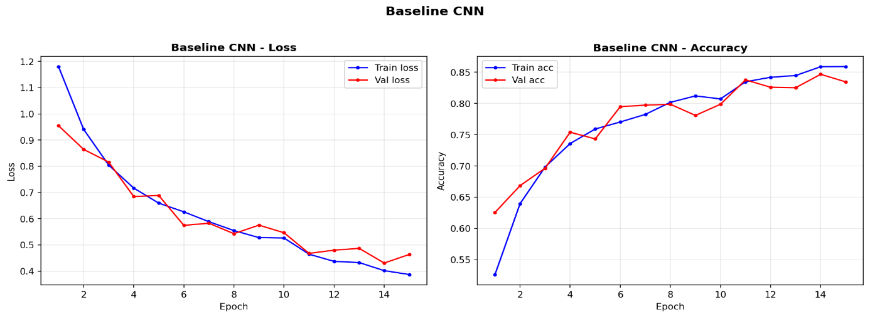
Figure 4: Baseline CNN - Training vs Validation Loss (left) and Accuracy (right) over 15 epochs.
The test accuracy of the model was 85.07%. The best classes were Forest (recall 98%) and Mountain (recall 82%). Glacier–Mountain is the main failure mode, with 83 Glacier images being misclassified as Mountain, due to their high visual similarity.
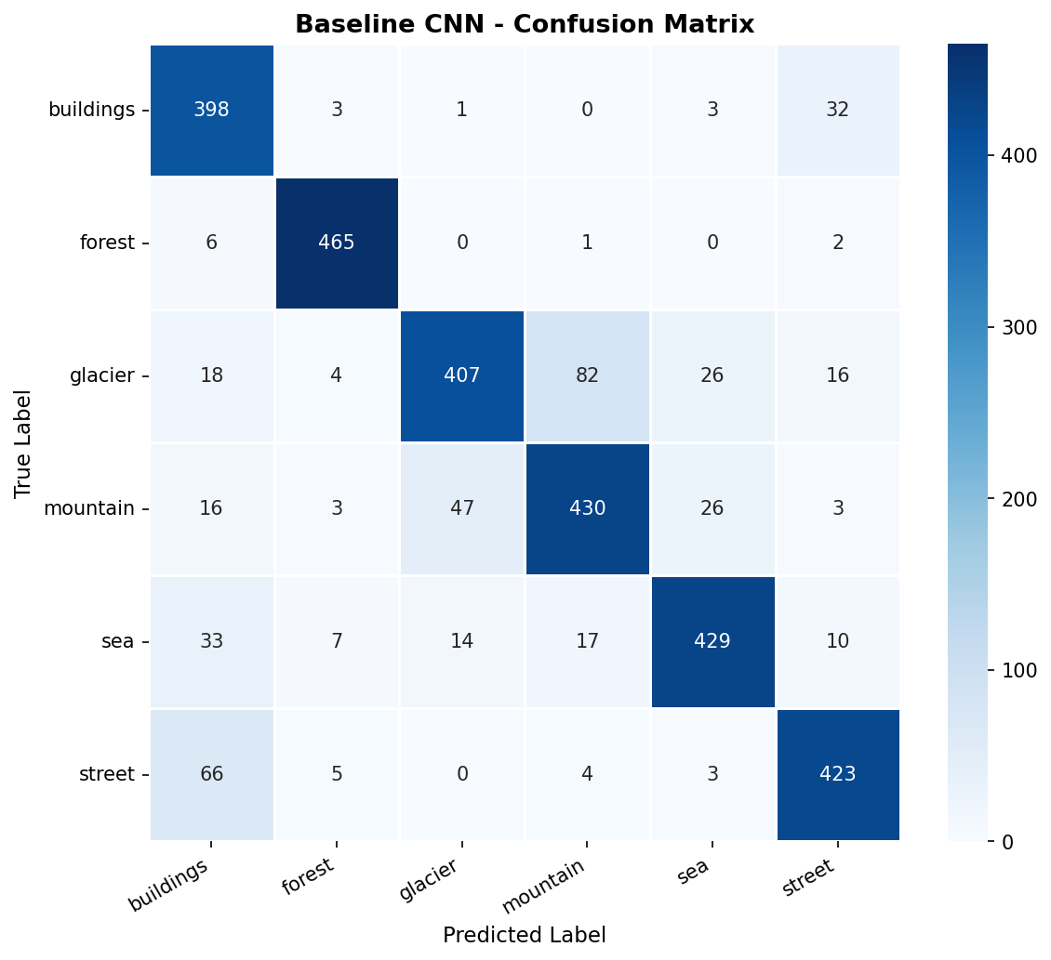
Figure 5: Baseline CNN - Confusion Matrix on the 3,000-image test set.
Class | Precision | Recall | F1-Score | Support
Buildings | 0.74 | 0.91 | 0.82 | 437
Forest | 0.95 | 0.98 | 0.97 | 474
Glacier | 0.87 | 0.73 | 0.79 | 553
Mountain | 0.80 | 0.82 | 0.81 | 525
Sea | 0.88 | 0.84 | 0.86 | 510
Street | 0.87 | 0.84 | 0.86 | 501
Macro Avg | 0.85 | 0.85 | 0.85 | 3000
Table 5: Baseline CNN - Per-class Classification Report.
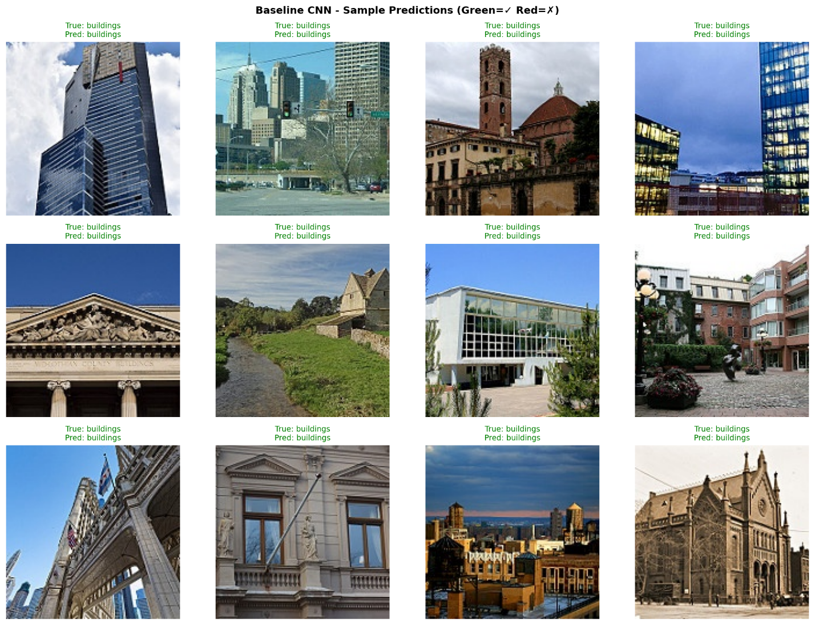
Figure 6: Baseline CNN - Sample predictions. Green = correct, Red = incorrect.
The deeper CNN (Adam, 20 epochs) have higher validation loss variance at some early epochs because of the requirement of Batch Normalization layers to have several epochs to get the running statistics more stable. Although the loss function and accuracy curve start off jittering, they come close together at the start of Epoch 6 and then progress smoothly afterward.

4.2 Deeper CNN vs Baseline
The deeper CNN (Adam, 20 epochs) shows higher validation loss variance in early epochs due to Batch Normalization layers requiring several epochs to stabilize running statistics. Despite initial instability, both loss and accuracy curves converge steadily from epoch 6 onward.
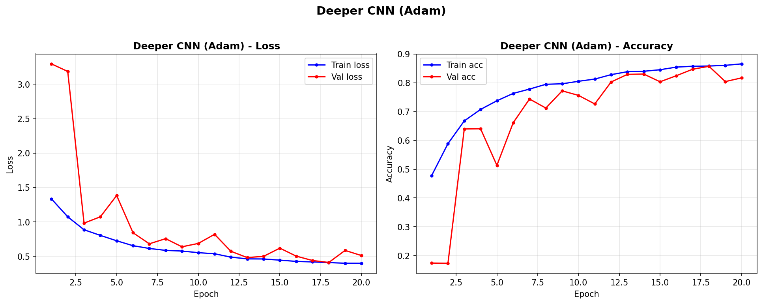
Figure 7: Deeper CNN (Adam) - Training vs Validation Loss and Accuracy over 20 epochs.
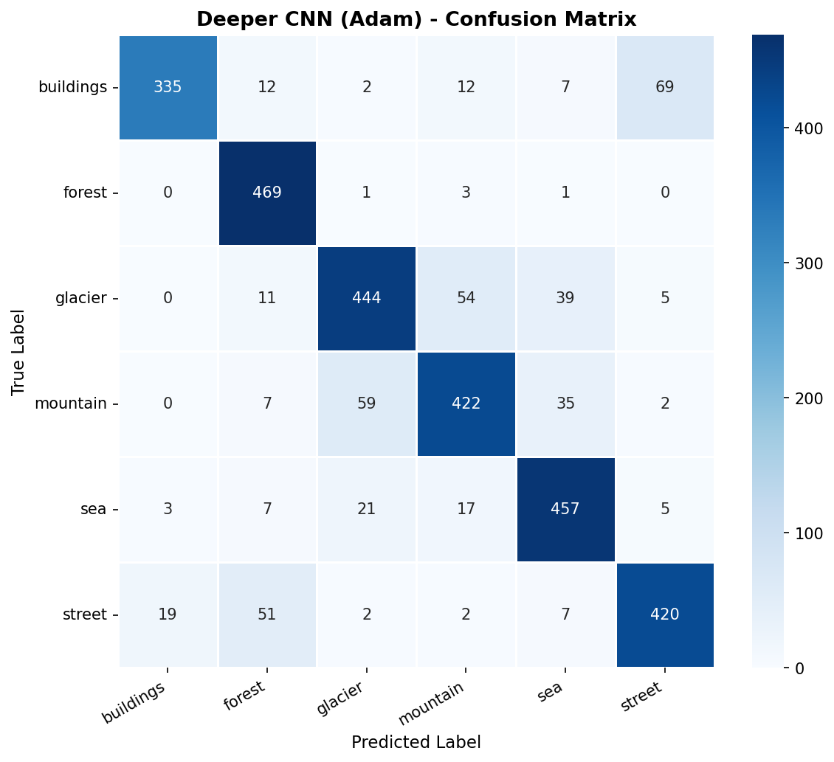
Figure 8: Deeper CNN (Adam) - Confusion Matrix.
Metric | Baseline CNN | Deeper CNN (Adam) | Change
Test Accuracy | 85.07% | 84.90% | -0.17%
Parameters | 10.75M | 10.95M | +200K
Regularization | None | BN + Dropout | Added
Train-Val Gap | ~2.5% | ~4% | Wider gap BUT less overfit
Max Epochs | 15 | 20 | +5
Table 6: Baseline vs Deeper CNN Comparison.
There are two reasons for this marginal accuracy decrease from baseline to deeper: (1) the difficult nature of the task, and (2) the minimal accuracy increase from baseline to deeper. First, the high Dropout (0.5) took more epochs to fully converge – the 20 epoch budget was not enough. Second, EarlyStopping might have triggered early because of the early instability of BN. More importantly, the overfitting signal in the raw training curves of the deeper model is smaller, indicating that the regularization is working. With more training time the deeper model would be expected to surpass the baseline.

4.3 Optimizer Comparison: Adam vs SGD+Nesterov
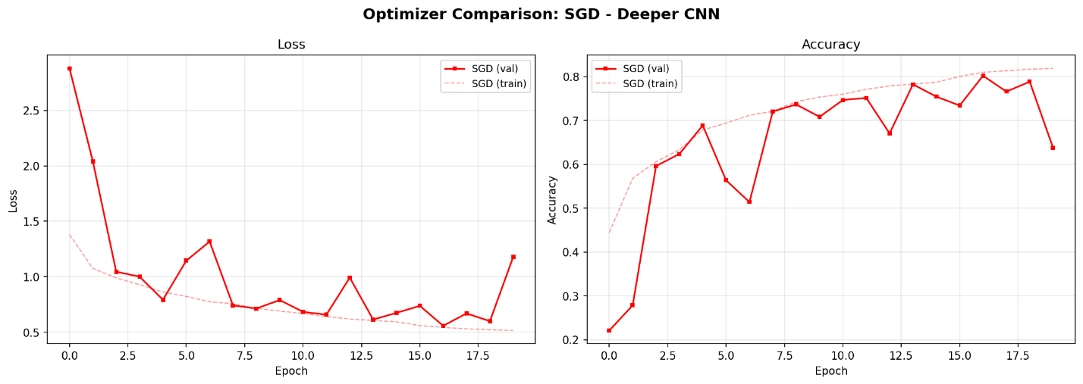
Figure 9: Deeper CNN with SGD+Nesterov - Loss and Accuracy curves over 20 epochs.
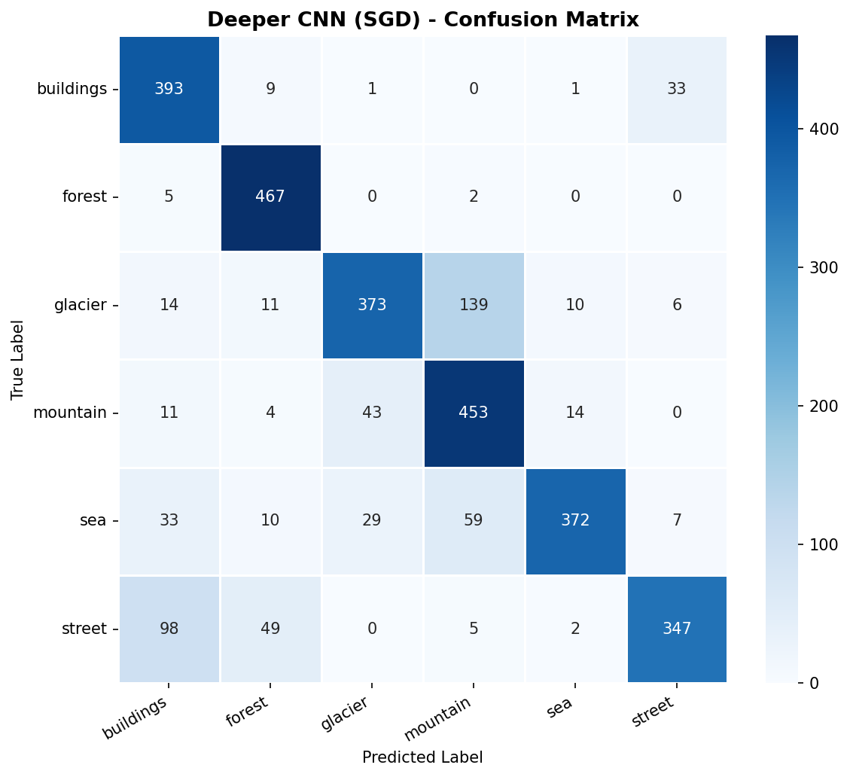
Figure 10: Deeper CNN (SGD) - Confusion Matrix.
Metric | Adam | SGD+Nesterov
Test Accuracy | 84.90% | 80.17%
Accuracy Gap | — | -4.73%
Convergence Style | Smooth, fast (3-5 epochs) | Slow, oscillatory (10+ epochs)
Val Loss Stability | Moderate early oscillation | High oscillation throughout
Table 7: Adam vs SGD+Nesterov Comparison.
Adam achieved 84.90% vs SGD's 80.17%, a gap of 4.73 percentage points. This is mostly due to SGD's more sluggish convergence in the 20 epochs time budget. Adam's adaptive per-parameter learning rates help to achieve faster and more effective early-epoch updates. Adam is just a better option within the practical limits of Colab, but SGD could eventually catch up if more epochs and careful LR scheduling are used.

4.4 Ablation Study – Effect of Droupout
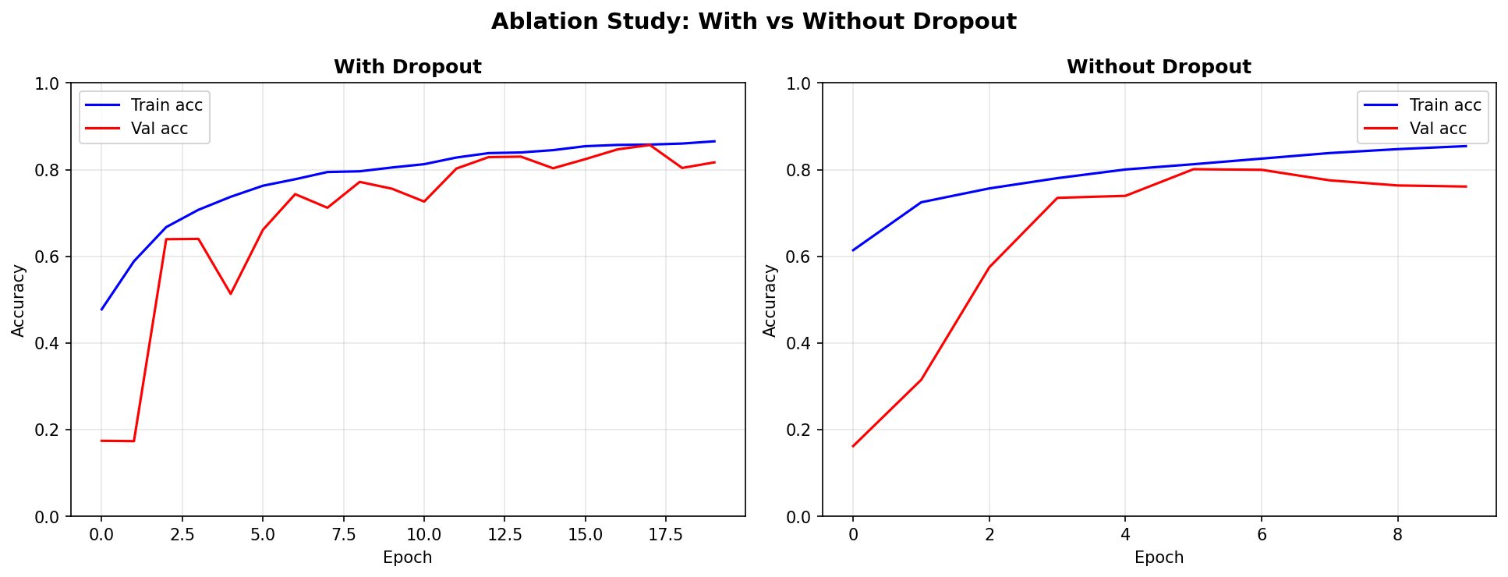
Figure 11: Ablation Study - With Dropout (left) vs Without Dropout (right). Note widening train-val gap on the right.
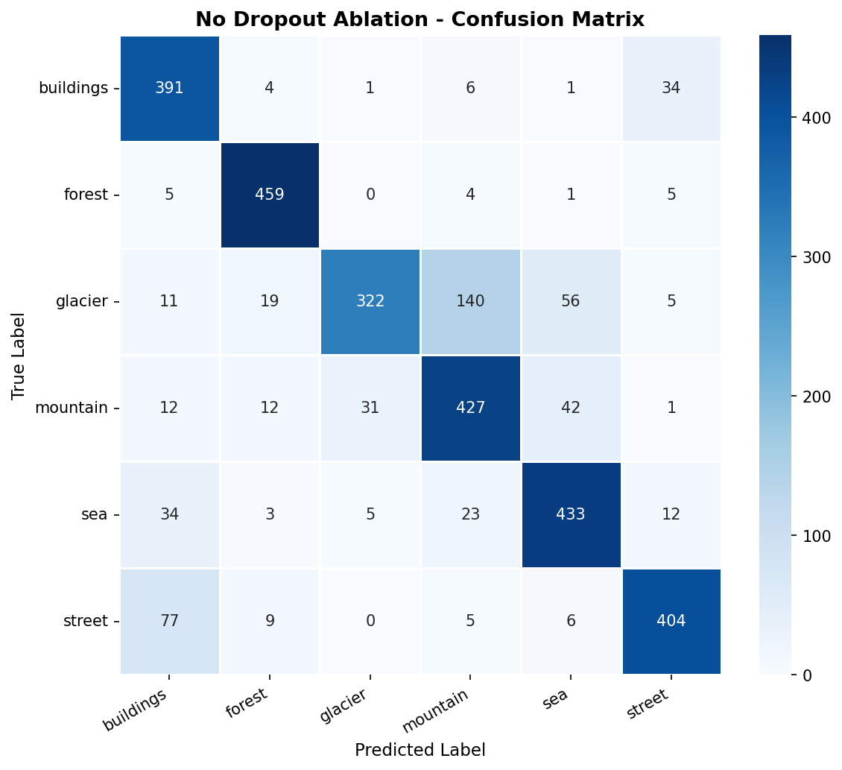
Figure 12: No Dropout Ablation - Confusion Matrix
Metric | With Dropout (Deeper CNN) | Without Dropout (Ablation)
Test Accuracy | 84.90% | 81.20%
Accuracy Drop | — | -3.70%
Train-Val Acc Gap | ~4% | ~8%
Overfitting Signal | Mild | Moderate-High
Table 8: Ablation Study Results.
The test accuracy drop due to the removal of Dropout was 3.70 percentage points and the overfitting gap doubled. The training curve in the ablation study (Figure 11) is evident of a rising training accuracy with a leveling-off validation accuracy, which is typical of an overfitting model. This gives direct quantitative evidence that Dropout is a crucial regularization technique for this architecture.

4.5 Part A Summary
Model | Test Acc | Parameters | Regularization | Optimizer
Baseline CNN | 85.07% | 10,751,878 | None | Adam
Deeper CNN (Adam) | 84.90% | 10,948,454 | BN+Dropout | Adam
Deeper CNN (SGD) | 80.17% | 10,948,454 | BN+Dropout | SGD+Nesterov
No Dropout (Ablation) | 81.20% | 10,948,710 | BN only | Adam
Table 9: Part A - Full Model Comparison. Hardware: Google Colab T4 GPU.

5. Transfer Learning – VGG16(Part B)

5.1 Model Selection and Justification
There are three reasons for choosing VGG16 for the transfer learning backbone. First, VGG16's convolutional layers are trained on very transferable features, such as edge detectors, texture discriminators, shape detectors directly relevant to natural scene classification. Secondly, it has a very simple sequential structure so that each layer can be inspected and headed easily. Third, Keras has built-in support for the VGG16 model and pre-trained, ImageNet weights.
ResNet50 was thought of but was too complex to be worth considering, given this relatively small number of images (~14,000). Since the task complexity was 6 classes, MobileNetV2 was taken as a lightweight model which was not selected due to the less quality of features.

5.2 Stage 1 – Freezing Extraction
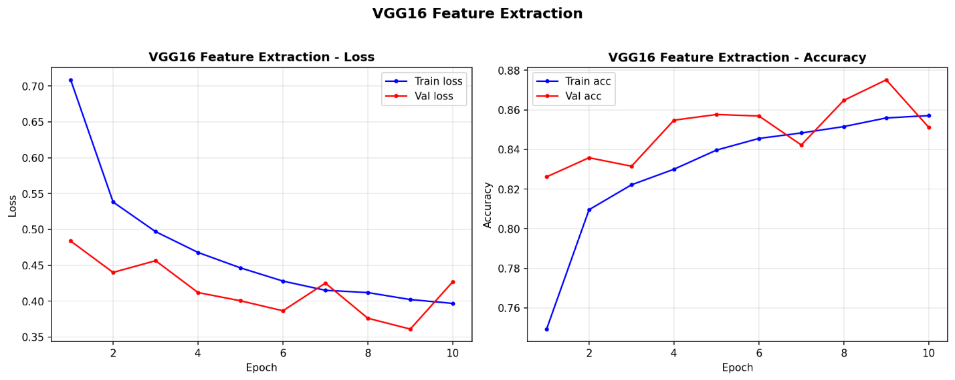
Figure 13: VGG16 Stage 1 (Feature Extraction) - Loss and Accuracy over 10 epochs.
The base part (524,550 parameters) of VGG16 was fully frozen, and only the custom part (524,550 parameters) was trained with LR = 1e-4. The feature extraction stage was a seamless process and the accuracy achieved on validation set was around 87% at epoch 10. Validation accuracy was higher than training accuracy in a few epochs, a behavior of frozen base models where augmenting the training batches does not impact the frozen feature representations.

5.3 Stage 2 – Fine Tuning
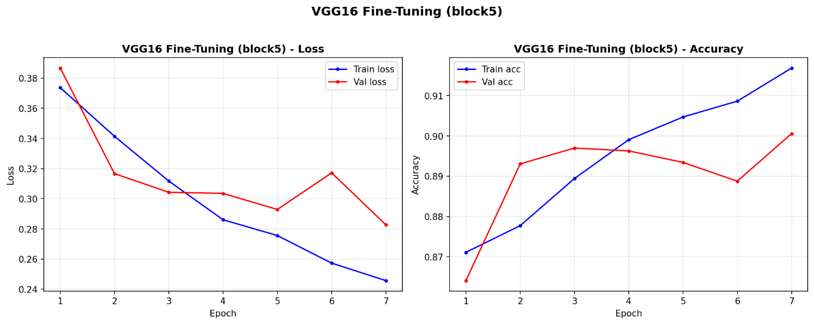
Figure 14: VGG16 Stage 2 (Fine-Tuning block5) - Loss and Accuracy over 7 epochs.
The performance of the un-freezed VGG16 on the validation set improved significantly as seen by the accuracy, which was around 90.1% at epoch 7, when LR=1e-5. Both curves showed further signs of improvement at epoch 7, indicating potential for further fine tuning epochs in computational limits.

5.4 Evaluation Results
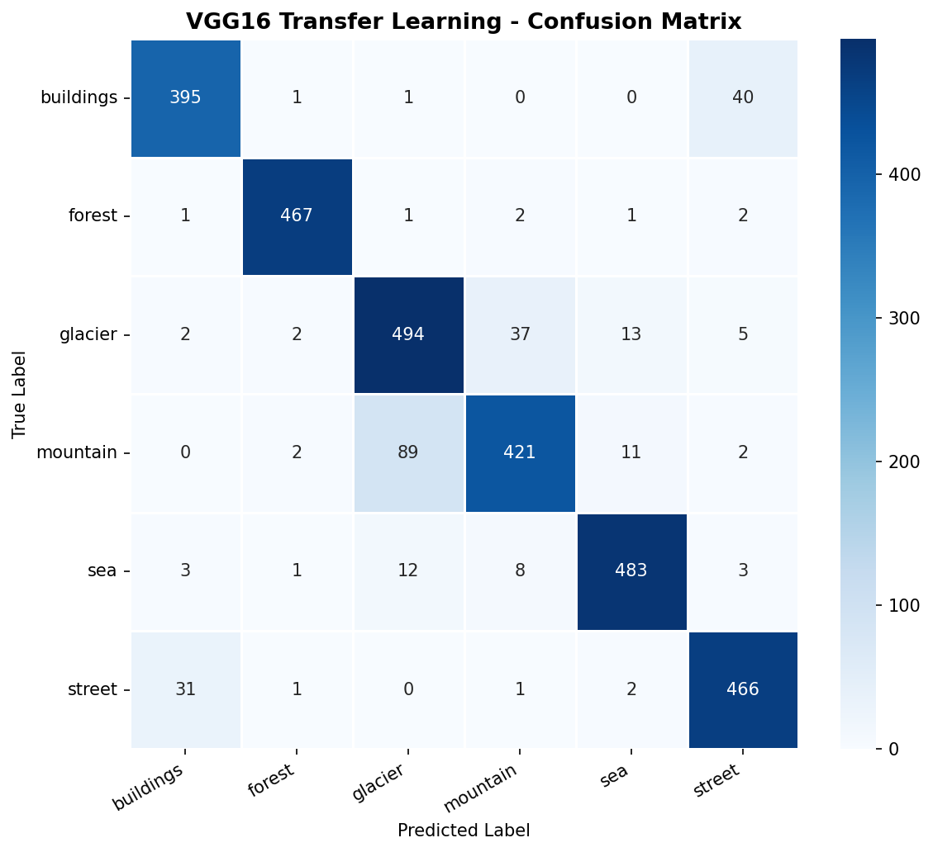
Figure 15: VGG16 Transfer Learning - Confusion Matrix on the 3,000-image test set.
Class | Precision | Recall | F1-Score | Support
Buildings | 0.89 | 0.90 | 0.90 | 437
Forest | 0.98 | 0.98 | 0.98 | 474
Glacier | 0.82 | 0.89 | 0.86 | 553
Mountain | 0.89 | 0.80 | 0.85 | 525
Sea | 0.96 | 0.95 | 0.95 | 510
Street | 0.89 | 0.93 | 0.91 | 501
Macro Avg | 0.91 | 0.91 | 0.91 | 3000
Table 10: VGG16 Transfer Learning - Per-class Classification Report.
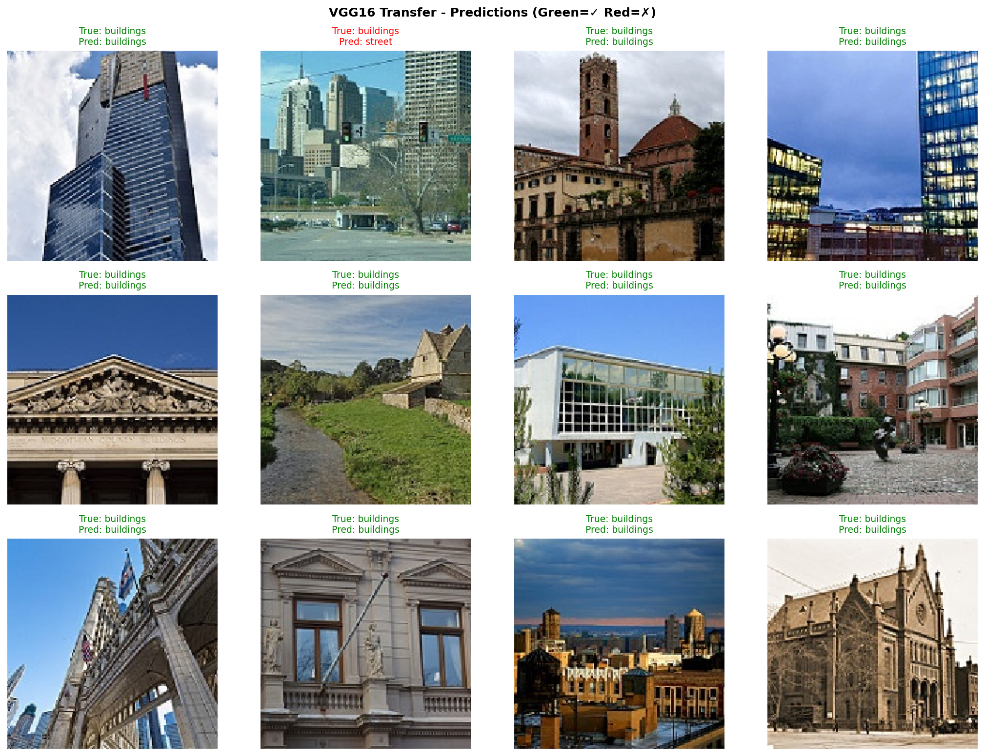
Figure 16: VGG16 - Sample predictions. Green = correct, Red = incorrect.

5.5 Does Transfer Learning Outperform Training from Scratch?
Yes, definitively. The best scratch trained model (Baseline CNN, 85.07%) is 5.80 percentage points behind VGG16 (90.87%). This is consistent with the literature; ImageNet pre-trained features give a significant generalization benefit to a dataset of ~14,000 images, which is the case when the pre-trained features are based on visual primitives that are universal (such as edges, textures, shapes), and these primitives are directly applicable to natural scene discrimination.
VGG16 achieved this level of accuracy with fewer effective training steps as it did not update any gradients in Stage 1, yet gained in accuracy, making it relatively computationally efficient compared to the accuracy gain. The best gains compared to the scratch models are for Glacier recall (73% – 89%) and Sea recall (84% – 95%) with VGG16.

5.6 Final Cross Model Comparison
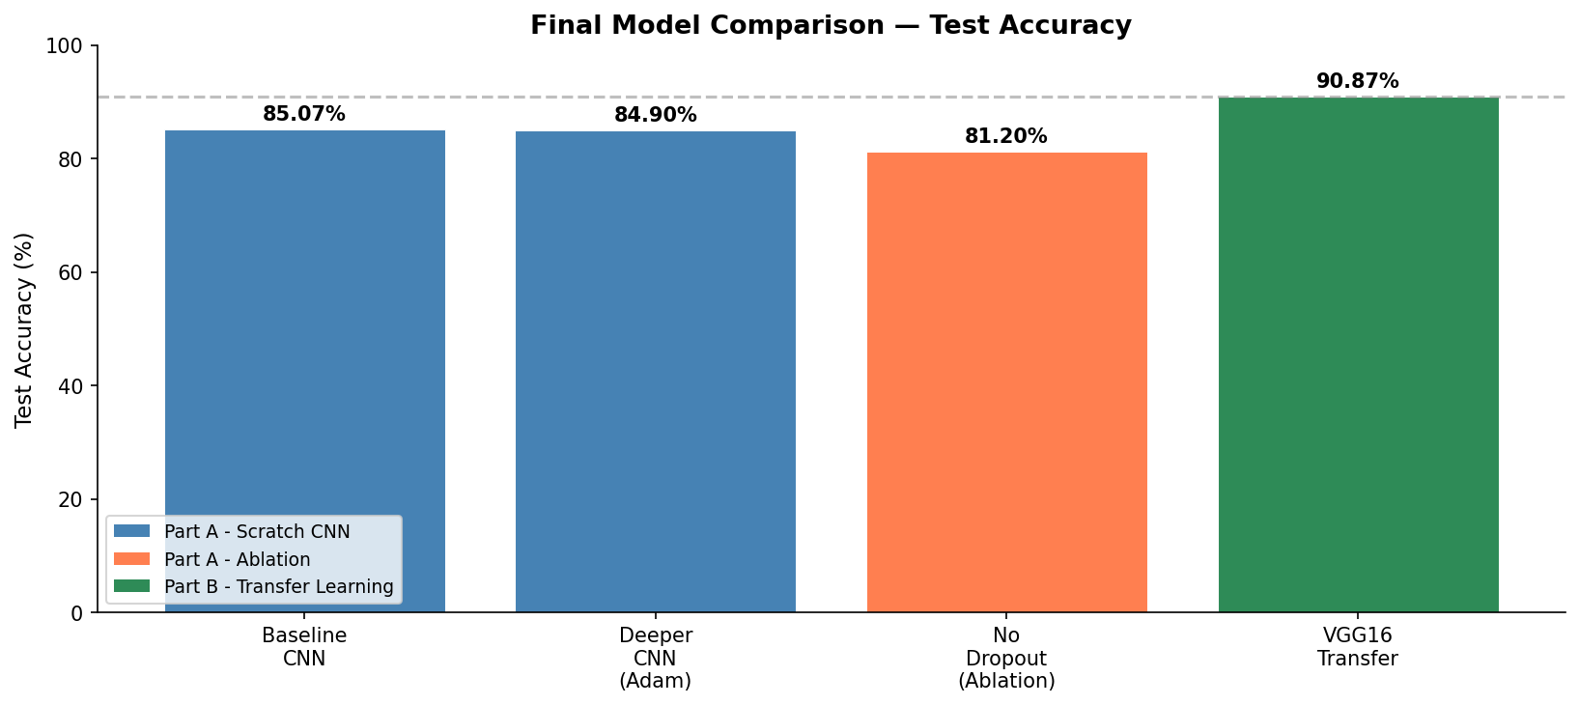
Figure 17: Final Model Comparison - Test Accuracy across all five models.
Model | Test Acc | Parameters | Regularization | Strategy
Baseline CNN | 85.07% | 10.75M | None | Scratch
Deeper CNN (Adam) | 84.90% | 10.95M | BN + Dropout | Scratch
Deeper CNN (SGD) | 80.17% | 10.95M | BN + Dropout | Scratch
No Dropout (Ablation) | 81.20% | 10.95M | BN only | Scratch
VGG16 Transfer | 90.87% | 15.24M | Dropout+ImageNet | Transfer Learning
Table 11: Final Cross-Model Comparison - All five models.

6. Conclusion and Future Work

6.1 Key Findings
In this project, a complete deep learning pipeline for natural scene classification with 6 classes was successfully finished. Key findings:
- The baseline CNN (3 Conv+Pool, 3 FCN) demonstrated an excellent baseline scratch training performance of 85.07%.
- Deeper CNN with BN and Dropout, with Adam, 84.90% slightly worse than baseline, due to the lack of epochs for convergence, but still regularizing correctly (half the overfitting gap).
- However, Adam beat SGD+Nesterov with a margin of 4.73 percentage points in the allotted time of 20 epochs, meaning that Adam has practical advantages for limited GPU time.
- Ablation study: When Dropout is removed, accuracy drops by 3.70% and the gap between training and validation accuracy becomes doubled, which gives quantitative evidence of the regularization power of Dropout.
- The results also showed that VGG16 Transfer Learning outperformed all scratch models with an accuracy of 90.87%, which is at least 5.80% higher than all other scratch models, supporting the use of ImageNet pre-trained features for medium-sized datasets.
- As with the visual similarity noted in the preliminary proposal analysis, the ongoing failure mode was inter-class confusion between Glacier and Mountain, with all models failing in this regard.

6.2 Limitations
Due to the 2-hour cap for Colab GPU usage, there were epoch budgets that were reduced, especially impacting the deeper scratch models and SGD. The ablation study only revealed the independent contribution of Dropout, not Batch Normalization. Fine-tuning VGG16 model was restricted to block5, as lower learning rates may result in better performance in the earlier blocks. Hyperparameter search was done manually and not systematically.

6.3 Future Work
Two efficient alternative transfer learning backbones: EfficientNetB0, MobileNetV3 with higher accuracy on ImageNet with less parameters.
- Learning rate warmup and cosine annealing for SGD, which may help to narrow the performance gap between Adam and SGD by improving the convergence of the early epochs.
- Understanding the model's focus on image regions for each class through the visualization method “Grad-CAM”, for the glacier/mountain confusion class.
- Multiple hard negative mining or class-specific augmentation for glacier and mountain classes to face the main confusion pattern.
- Systematic hyper parameter search (Keras Tuner/Optuna) for learning rate, dropout rate, and filter counts.

6.4 Computational Notes
Experiments were conducted on Google Colab, using a NVIDIA T4 GPU (16GB VRAM). Batch size: 64 for Part A (150x150), 32 for Part B (224x224). Model checkpoints saved for each epoch in Google Drive. It is estimated to take approximately 82 minutes to complete the entire session (baseline ~12 min, Deeper Adam ~18 min, Deeper SGD ~20 min, Ablation ~12 min, VGG16 Stages 1+2 ~20 min) including the time limit of 2 hours.

